Apply for licenses and permits

Federal licenses and permits
You'll need to get a federal license or permit if your business activities are regulated by a federal agency.
Check to see if any of your business activities are listed here, and then check with the right federal agency to see how to apply.
Requirements and fees depend on your business activity and the agency issuing the license or permit. It's best to check with the issuing agency for details on the business license cost.
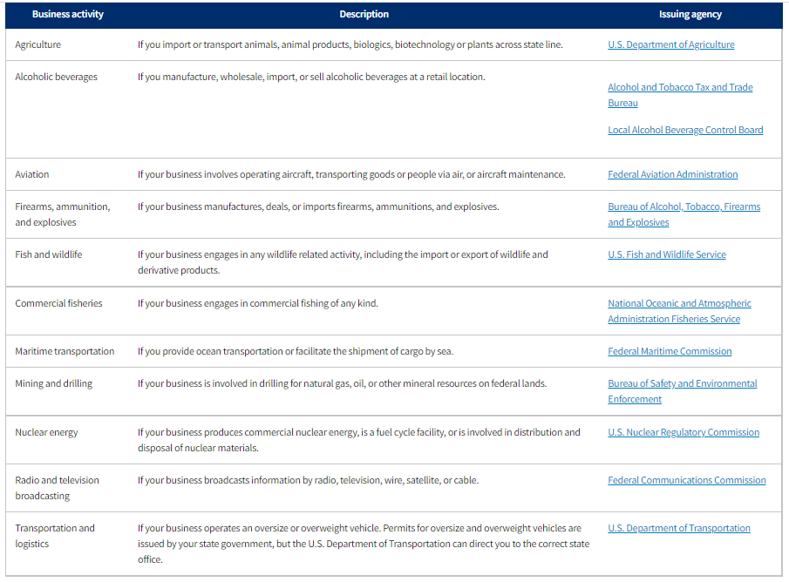

State licenses and permits
The licenses and permits you need from the state, county, or city will depend on your business activities and business location. Your business license fees will also vary.
States tend to regulate a broader range of activities than the federal government. For example, business activities that are commonly regulated locally include auctions, construction, and dry cleaning, farming, plumbing, restaurants, retail, and vending machines.
Some licenses and permits expire after a set period of time. Keep close track of when you need to renew them — it's often easier to renew than it is to apply for a new one.
You'll have to research your own state, county, and city regulations. Industry requirements often vary by state. Visit your state's website to find out which permits and licenses you need.

