Choose a business structure
Your business structure affects how much you pay in taxes, your ability to raise money, the paperwork you need to file, and your personal liability.
You'll need to choose a business structure before you register your business with the state. Most businesses will also need to get a tax ID number and file for the appropriate licenses and permits.
Choose carefully. While you may convert to a different business structure in the future, there may be restrictions based on your location. This could also result in tax consequences and unintended dissolution, among other complications.
Consulting with business counsellors, attorneys, and accountants can prove helpful.

Review common business structures

Sole proprietorship
A sole proprietorship is easy to form and gives you complete control of your business. You're automatically considered to be a sole proprietorship if you do business activities but don't register as any other kind of business.
Sole proprietorships do not produce a separate business entity. This means your business assets and liabilities are not separate from your personal assets and liabilities. You can be held personally liable for the debts and obligations of the business. Sole proprietors are still able to get a trade name. It can also be hard to raise money because you can't sell stock, and banks are hesitant to lend to sole proprietorships.
Sole proprietorships can be a good choice for low-risk businesses and owners who want to test their business idea before forming a more formal business.

Partnership
Partnerships are the simplest structure for two or more people to own a business together. There are two common kinds of partnerships: limited partnerships (LP) and limited liability partnerships (LLP).
Limited partnerships have only one general partner with unlimited liability, and all other partners have limited liability. The partners with limited liability also tend to have limited control over the company, which is documented in a partnership agreement. Profits are passed through to personal tax returns, and the general partner — the partner without limited liability — must also pay self-employment taxes.
Limited liability partnerships are similar to limited partnerships, but give limited liability to every owner. An LLP protects each partner from debts against the partnership, they won't be responsible for the actions of other partners.
Partnerships can be a good choice for businesses with multiple owners, professional groups (like attorneys), and groups who want to test their business idea before forming a more formal business.

Limited liability company (LLC)
An LLC lets you take advantage of the benefits of both the corporation and partnership business structures.
LLCs protect you from personal liability in most instances, your personal assets — like your vehicle, house, and savings accounts — won't be at risk in case your LLC faces bankruptcy or lawsuits.
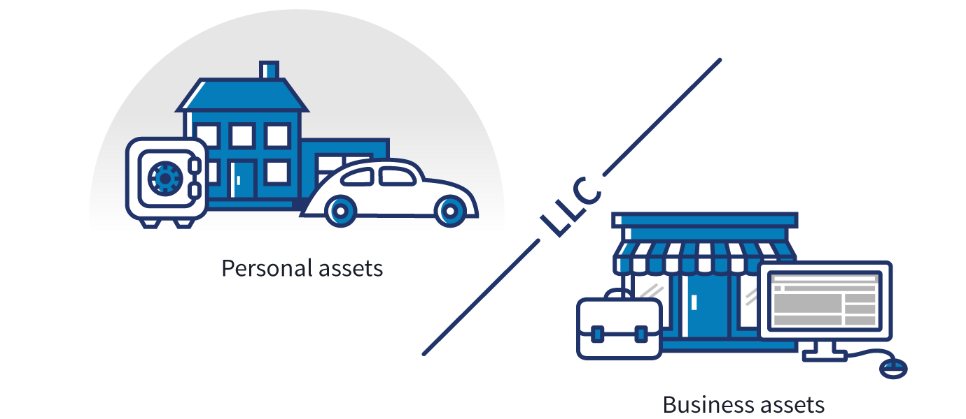
Profits and losses can get passed through to your personal income without facing corporate taxes. However, members of an LLC are considered self-employed and must pay self-employment tax contributions towards Medicare and Social Security.
LLCs can have a limited life in many states. When a member joins or leaves an LLC, some states may require the LLC to be dissolved and re-formed with new membership — unless there's already an agreement in place within the LLC for buying, selling, and transferring ownership.
LLCs can be a good choice for medium- or higher-risk businesses, owners with significant personal assets they want protected, and owners who want to pay a lower tax rate than they would with a corporation.

Corporation

C corp
A corporation, sometimes called a C corp, is a legal entity that's separate from its owners. Corporations can make a profit, be taxed, and can be held legally liable.
Corporations offer the strongest protection to its owners from personal liability, but the cost to form a corporation is higher than other structures. Corporations also require more extensive record-keeping, operational processes, and reporting.
Unlike sole proprietors, partnerships, and LLCs, corporations pay income tax on their profits. In some cases, corporate profits are taxed twice — first, when the company makes a profit, and again when dividends are paid to shareholders on their personal tax returns.
Corporations have a completely independent life separate from its shareholders. If a shareholder leaves the company or sells his or her shares, the C corp can continue doing business relatively undisturbed.
Corporations have an advantage when it comes to raising capital because they can raise funds through the sale of stock, which can also be a benefit in attracting employees.
Corporations can be a good choice for medium- or higher-risk businesses, those that need to raise money, and businesses that plan to "go public" or eventually be sold.

S corp
An S corporation, sometimes called an S corp, is a special type of corporation that's designed to avoid the double taxation drawback of regular C corps. S corps allow profits, and some losses, to be passed through directly to owners' personal income without ever being subject to corporate tax rates.
Not all states tax S corps equally, but most recognize them the same way the federal government does and tax the shareholders accordingly. Some states tax S corps on profits above a specified limit and other states don't recognize the S corp election at all, simply treating the business as a C corp.
S corps must file with the IRS to get S corp status, a different process from registering with their state.
There are special limits on S corps. Check the IRS website for eligibility requirements. You'll still have to follow the strict filing and operational processes of a C corp.
S corps also have an independent life, just like C corps. If a shareholder leaves the company or sells his or her shares, the S corp can continue doing business relatively undisturbed.
S corps can be a good choice for a business that would otherwise be a C corp, but meet the criteria to file as an S corp.

B corp
A benefit corporation, sometimes called a B corp, is a for-profit corporation recognized by a majority of U.S. states. B corps are different from C corps in purpose, accountability, and transparency, but aren't different in how they're taxed.
B corps are driven by both mission and profit. Shareholders hold the company accountable to produce some sort of public benefit in addition to a financial profit. Some states require B corps to submit annual benefit reports that demonstrate their contribution to the public good.
There are several third-party B corp certification services, but none are required for a company to be legally considered a B corp in a state where the legal status is available.

Close corporation
Close corporations resemble B corps but have a less traditional corporate structure. These shed many formalities that typically govern corporations and apply to smaller companies.
State rules vary, but shares are usually barred from public trading. Close corporations can be run by a small group of shareholders without a board of directors.

Non-profit corporation
Non-profit corporations are organized to do charity, education, religious, literary, or scientific work. Because their work benefits the public, non-profits can receive tax-exempt status, meaning they don't pay state or federal income taxes on any profits it makes.
Non-profits must file with the IRS to get tax exemption, a different process from registering with their state.
Non-profit corporations need to follow organizational rules very similar to a regular C corp. They also need to follow special rules about what they do with any profits they earn. For example, they can't distribute profits to members or political campaigns.
Non-profits are often called 501(c)(3) corporations — a reference to the section of the Internal Revenue Code that is most commonly used to grant tax-exempt status.

Cooperative
A cooperative is a business or organization owned by and operated for the benefit of those using its services. Profits and earnings generated by the cooperative are distributed among the members, also known as user-owners. Typically, an elected board of directors and officers run the cooperative while regular members have voting power to control the direction of the cooperative. Members can become part of the cooperative by purchasing shares, though the amount of shares they hold does not affect the weight of their vote.

Combine different business structures
Designations like S corp and non-profit aren't strictly business structures — they can also be understood as a tax status. It's possible for an LLC to be taxed as a C corp, S corp, or a non-profit. These arrangements are far less common and can be more difficult to set up. If you're considering one of these non-standard structures, you should speak with a business counsellor or an attorney to help you decide.

Compare business structures
Compare the general traits of these business structures, but remember that ownership rules, liability, taxes, and filing requirements for each business structure can vary by state. The following table is intended only as a guideline. Please confer with a business tax specialist to confirm your specific business needs.

