Choose your business name

Register your business name to protect it
You’ll want to choose a business name that reflects your brand identity and doesn’t clash with the types of goods and services you offer.
Once you settle on a name you like, you need to protect it. There are four different ways to register your business name. Each way of registering your name serves a different purpose, and some may be legally required depending on your business structure and location.
- Entity name protects you at a state level
- Trademark protects you at a federal level
- Doing business as (DBA) doesn’t give legal protection, but it might be legally required
- Domain name protects your business website address
Each of these name registrations are legally independent. Most small businesses try to use the same name for each kind of registration, but you’re not normally required to.


Entity name
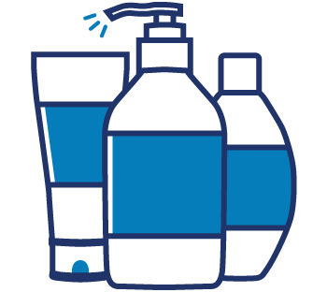

Trademark
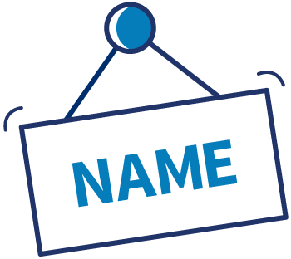

DBA


Four different ways to register your business name

Entity name
An entity name can protect the name of your business at a state level. Depending on your business structure and location, the state may require you to register a legal entity name.
Your entity name is how the state identifies your business. Each state may have different rules about what your entity name can be and usage of company suffixes. Most states don’t allow you to register a name that’s already been registered by someone else, and some states require your entity name to reflect the kind of business it represents.
In most cases, your entity name registration protects your business and prevents anyone else in the state from operating under the same entity name. However, there are exceptions pertaining to state and business structure.
Check with your state for rules about how to register your business name.

Trademark
A trademark can protect the name of your business, goods, and services at a national level. Trademarks prevent others in the same (or similar) industry in the United States from using your trademarked names.
For example, if you were an electronics company and wanted to call your business Springfield Electronic Accessories and one of your products Screen Cover 5000, trademarking those names would prevent other electronics businesses or similar products from using those same names.
Businesses in every state are subject to trademark infringement lawsuits, which can prove costly. That’s why you should check your prospective business, product, and service names against the official trademark database, maintained by the United States Patent and Trademark Office.

Doing business as (DBA) name
You might need to register your DBA — also known as a trade name, fictitious name, or assumed name — with the state, county, or city your business is located in. Registering your DBA name doesn’t provide legal protection by itself, but most states require you to register your DBA if you use one. Some business structures require you to use a DBA.
Even if you’re not required to register a DBA, you might want to anyway. A DBA lets you conduct business under a different identity from your own personal name or your formal business entity name. As an added bonus, getting a DBA and federal tax ID number (EIN) allows you to open a business bank account.
Multiple businesses can go by the same DBA in one state, so you’re less restricted in what you can choose. There’s also more leeway in the clarity of business function. For example, a small business owner could use Springfield Electronic Accessories for their entity name but use Tec Buddy for their DBA. Just remember that trademark infringement laws will still apply.
Determine your DBA requirements based on your specific location. Requirements vary by business structure as well as by state, county, and municipality, so check with local government offices and websites.

Domain name
If you want an online presence for your business, start by registering a domain name — also known as your website address, or URL.
Once you register your domain name, no one else can use it for as long as you continue to own it. It’s a good way to protect your brand presence online.
If someone else has already registered the domain you wanted to use, that’s okay. Your domain name doesn’t actually need to be the same as your legal business name, trademark, or DBA. For example, Springfield Electronic Accessories could register the domain name techbuddyspringfield.com.
You’ll register your domain name through a registrar service. Consult a directory of accredited registrars to determine which ones are safe to use, and then pick one that offers you the best combination of price and customer service. You’ll need to renew your domain registration on a regular basis.

