Register your business

Find out if you need to register your business
Your location and business structure determine how you’ll need to register your business. Determine those factors first, and registration becomes very straightforward.
For most small businesses, registering your business is as simple as registering your business name with state and local governments.
In some cases, you don’t need to register at all. If you conduct business as yourself using your legal name, you won’t need to register anywhere. But remember, if you don’t register your business, you could miss out on personal liability protection, legal benefits, and tax benefits.

Register with federal agencies
Most businesses don't need to register with the federal government to become a legal entity, other than simply filing to get a federal tax ID. Small businesses sometimes register with the federal government for trademark protection or tax exempt status.
If you want to trademark your business, brand or product name, file with the United States Patent and Trademark office once you’ve formed your business.
If you want tax-exempt status for a non-profit corporation, register your business as a tax-exempt entity with the IRS.
To create an S corp, you’ll need to file form 2553 with the IRS.
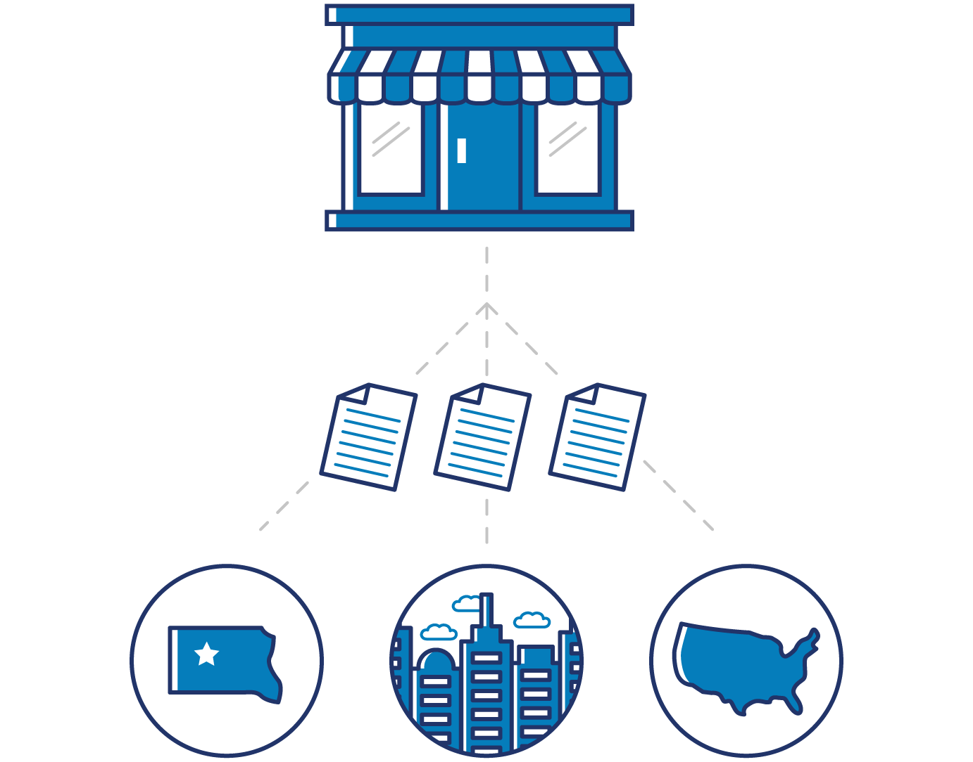

Register with state agencies
If your business is a limited liability company (LLC), corporation, partnership, or nonprofit corporation, you'll probably need to register with any state where you conduct business activities.
Typically, you’re considered to be conducting business activities in a state when:
- Your business has a physical presence in the state
- You often have in-person meetings with clients in the state
- A significant portion of your company’s revenue comes from the state
- Any of your employees work in the state
Some states allow you to register online, and some states make you file paper documents in person or through the mail.
Most states require you to register with the Secretary of State’s office, a Business Bureau, or a Business Agency.

Get a registered agent
If your business is an LLC, corporation, partnership, or non-profit corporation, you'll need a registered agent in your state before you file.
A registered agent receives official papers and legal documents on behalf of your company. The registered agent must be located in the state where you register.
Many business owners prefer to use a registered agent service rather than take on this role themselves.

File for foreign qualification
If your LLC, corporation, partnership, or non-profit corporation conducts business activities in more than one state, you might need to form your business in one state and then file for foreign qualification in other states where your business is active.
The state where you form your business will consider your business to be domestic, while every other state will view your business as foreign. Foreign qualification notifies the state that a foreign business is active there.
Foreign qualified businesses typically need to pay taxes and annual report fees in both their state of formation and states where they’re foreign qualified.
To foreign qualify, file a Certificate of Authority with the state. Many states also require a Certificate of Good Standing from your state of formation. Each state charges a filing fee, but the amount varies by state and business structure.
Check with state offices to find out foreign qualification requirements and fees.

File state documents and fees
In most cases, the total cost to register your business will be less than $300, but fees vary depending on your state and business structure.
The information you’ll need typically includes:
- Business name
- Business location
- Ownership, management structure, or directors
- Registered agent information
- Number and value of shares (if you’re a corporation)

The documents you need — and what goes in them — will vary based on your state and business structure.
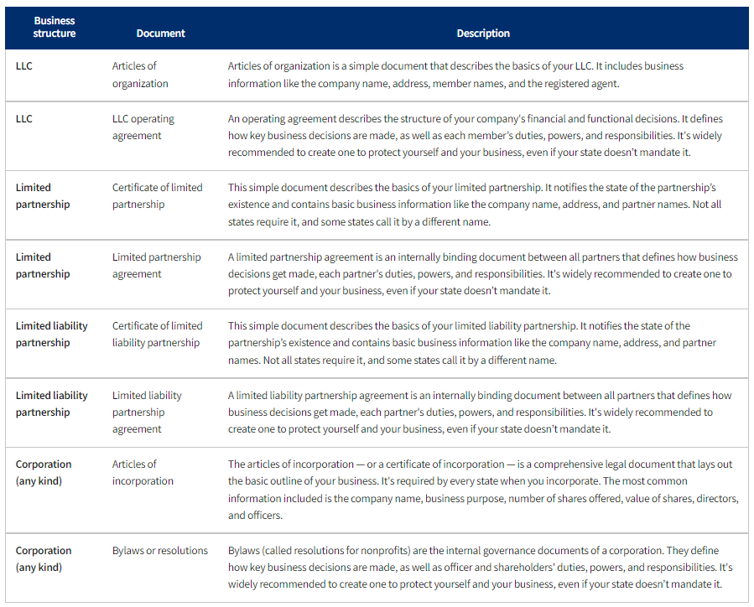

Register with local agencies
Typically, you don’t need to register with county or city governments to actually form your business.
If your business is an LLC, corporation, partnership, or non-profit corporation, you might need to file for licenses and permits from the county or city.
Some counties and cities also require you to register your DBA — a trade name or a fictitious name — if you use one.
Local governments determine registration, licensing, and permitting requirements, so visit local government websites to find out what you need to do.

Stay up to date with registration requirements
Some states require you to provide reports soon after registering depending on your business structure.
You may need to file additional documentation with your state tax board or franchise tax board. These filings are typically referred to as Initial Reports or Tax Board registration, and most often need to be filed within 30-90 days after you register with the state.
Check with your local tax office or franchise tax board, if it applies to you.

